Page one:
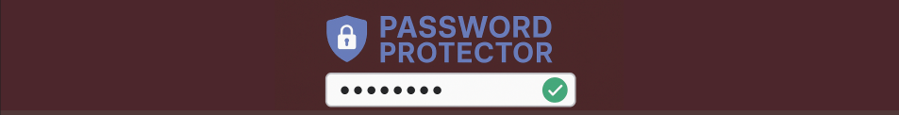
top bar: I used chat GPT to generate a top bar image that suited the theme of the website (being a password checker) This means that the audience before reading their first piece of content know exactly what the purpose of the website is. I placed it in the top left because most English speaking people read form top left onwards so by strategically placing it there the branding is the first thing the customer sees.
Nav bar- I made my nav bar a slightly different shade of the same colour to make the website more palatable for the consumer as well as to help to draw attention to each segment. In essence you are categorising each block of text by changing it’s shade. This will help the customer to associate new information with information they were given earlier in the website.

